* 1. **OPERATION OF COMPONENTS**
* **ULTRASONIC SENSOR**

The Arduino Ultrasonic Range Detection Sensor with Arduino calculates distance from objects. The output of an LED alters with PWM according to how close an object is to the sensor. So, nearer the object the brighter the LED . This Sensor works by sending an ultrasound pulse at around 40 KHz. It then gets the echo back and calculates the time taken in µsec. We can trigger a pulse as fast as 20 times a second and it can determine objects up to 3 meters away and as near as 3cm. It needs a 5V power supply to run. Arduino can be added to Ultrasonic Range Detection Sensor using only 4 pins Power, Ground, Trigger and Echo. Since it needs 5V and Arduino provides 5V, we will use this to power it. There are 2 sets of 5 pins, 1 set we can use, the other is for programming the PIC chip. Supply module with 5V, the output will be 5V while obstacle in range, or 0V if not. The out pin of this module is used as a switching output when anti-theft module .

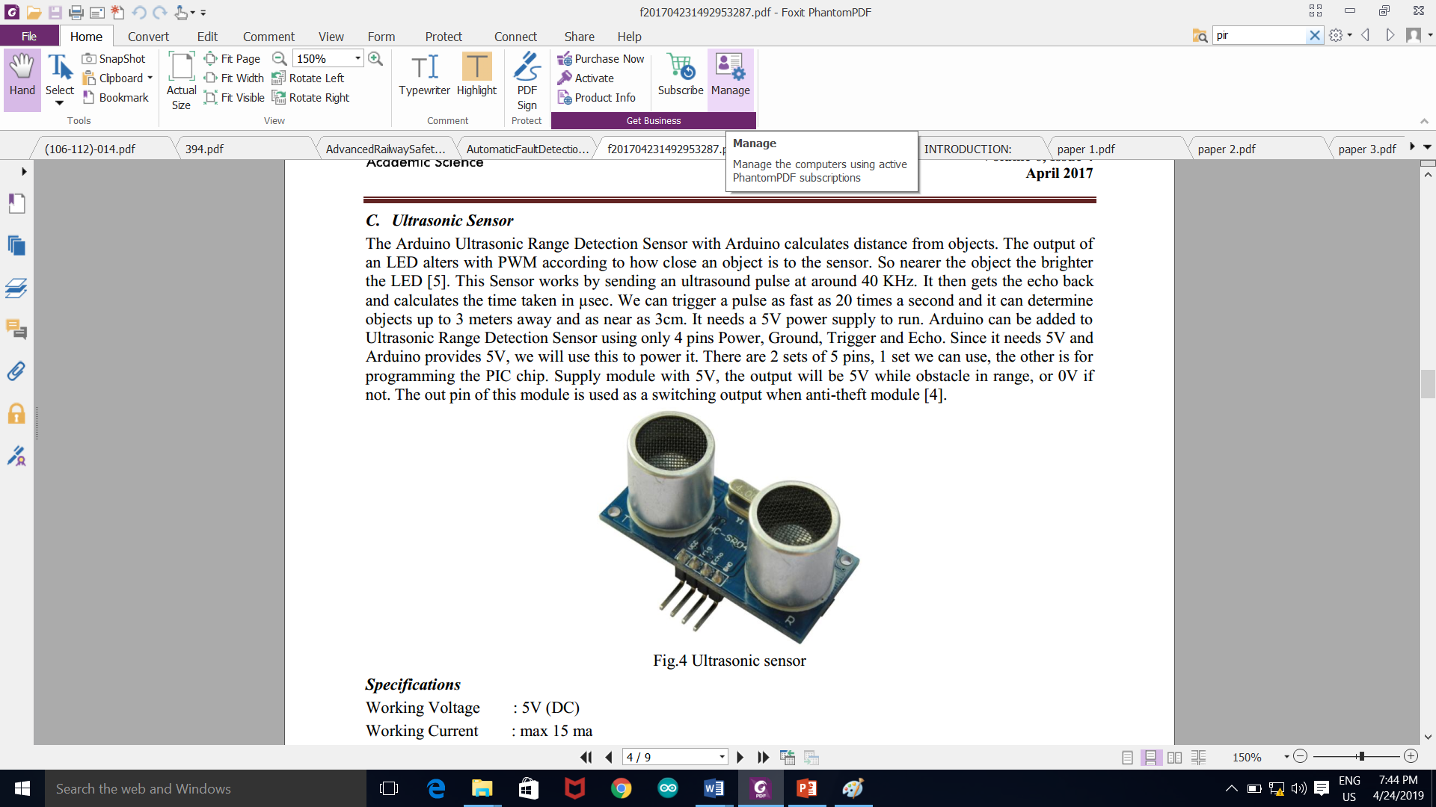

Fig.4 Ultrasonic sensor

Specifications  
Working Voltage : 5V (DC)

Working Current : max 15 ma

Operating frequency: 40HZ

Output Signal : 0-5V (Output high when obstacle in range)

Sentry Angle : max 15 degree

Sentry Distance : 2cm - 500cm

High-accuracy : 0.3cm

Input trigger signal : 10us TTL impulse

Echo signal : output TTL PWL signal

Size : 45*20*15mm

Interface

Pin:1 VCC

Pin:2 Trigger(T)

Pin:3 Echo(R)

Pin:4 GND

Module Working Principle

1.Adopt IO trigger through supplying at least 10µs sequence of high level signal.

2. The module automatically sends eight 40 kHz square wave and automatically detect returning pulse signal,

3. If there are signals returning through outputting high level and the time of high level continuing is the time of that from the ultrasonic transmitting to receiving. Test distance = (high level time * sound velocity (340M/S) / 2.

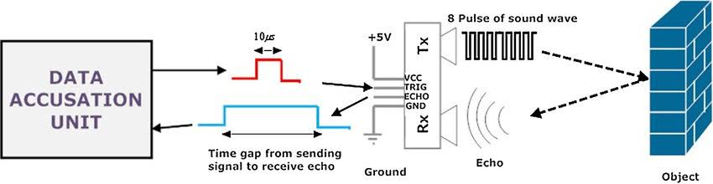

* **Arduino UNO/MEGA**

The Arduino UNO is a microcontroller board based on the ATmega328.Arduino is open-source electronics prototyping platform and it is intended for designing, creating interactive objects or environments. Arduino boards are relatively inexpensive compared to other microcontroller platforms. A basic Arduino Uno board has been shown in Fig.3

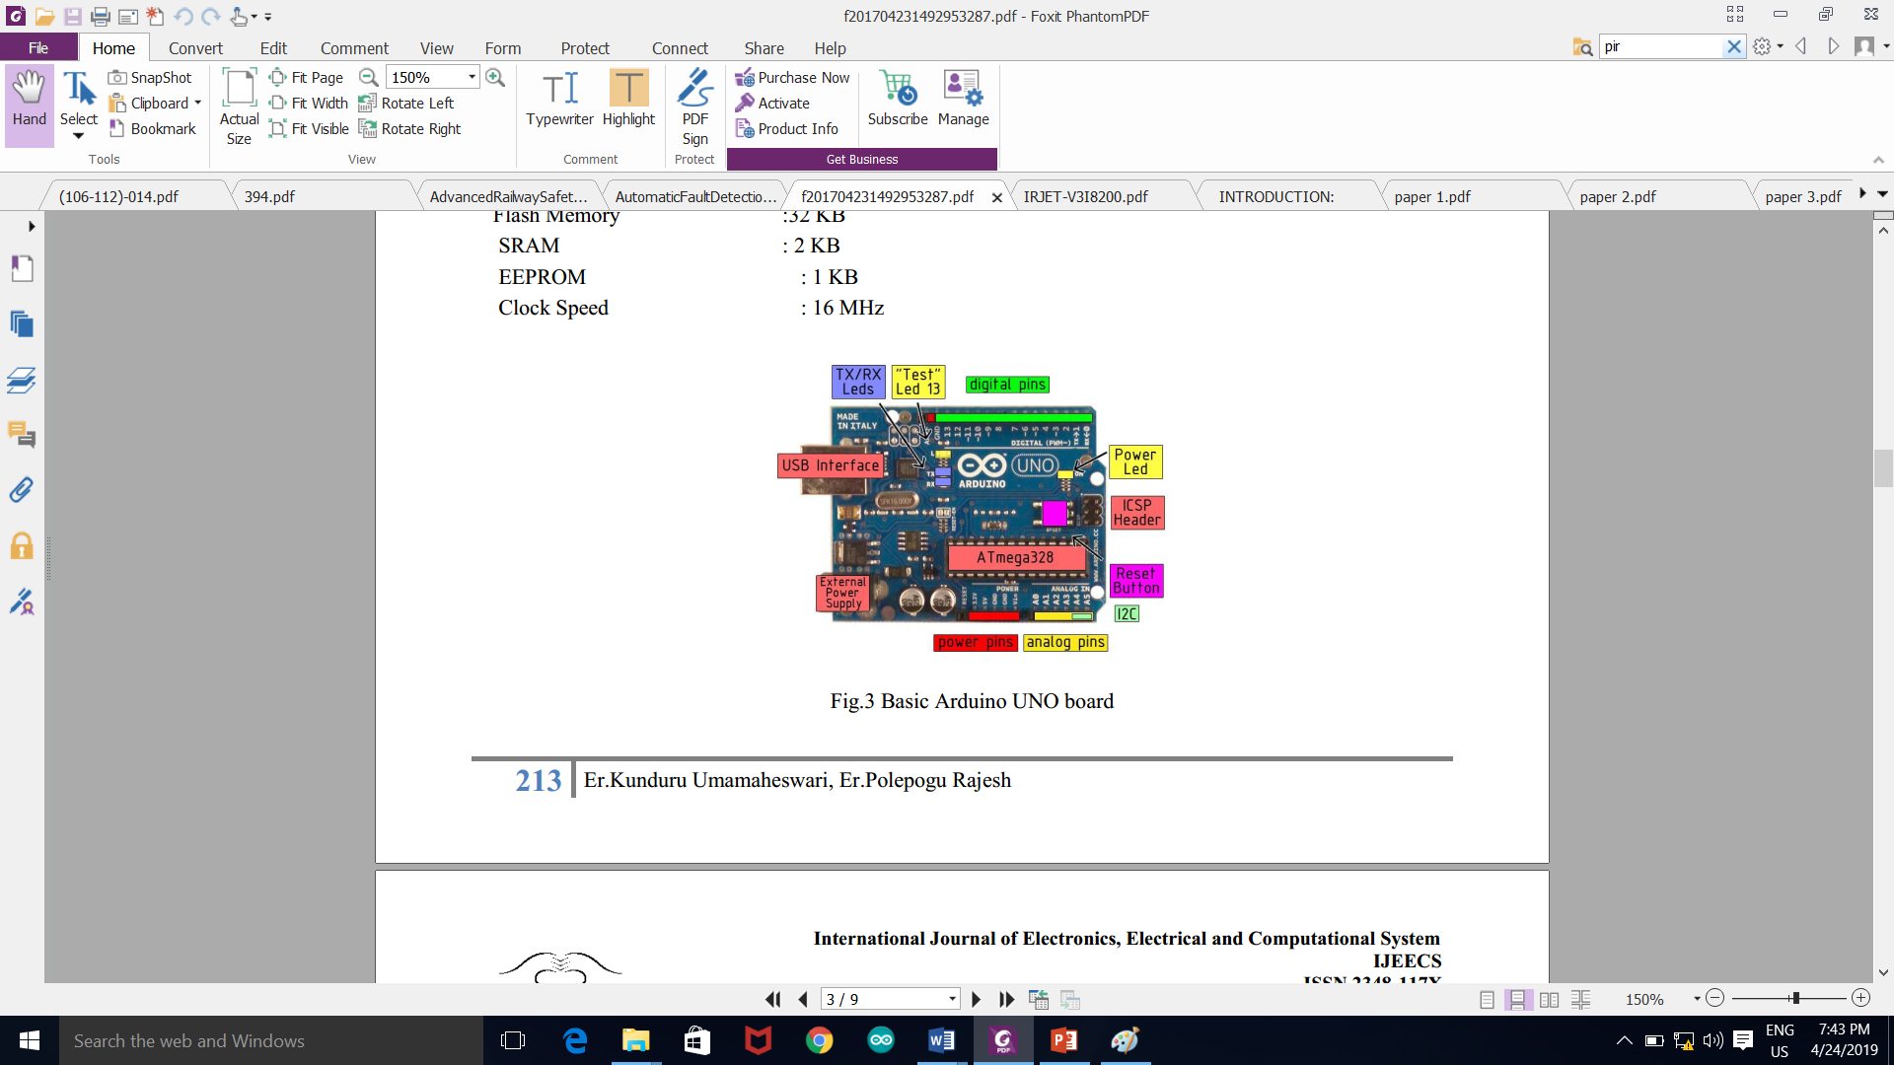

**Features:**1. Cross-platform

The Arduino software runs on Windows, Macintosh OSX, and Linux operating systems.  
2. Simple, clear programming environment

The Arduino programming environment is easy-to-use for beginners and flexible enough for the advanced users.

3. Source and extensible software

The Arduino software is published as open source Open tools, available for extension by experienced programmers. The language can be expanded through C++ libraries.  
4. Open source and extensible hardware.

**Technical Specifications**

|  |  |
| --- | --- |
| Microcontroller | ATmega328 |
| Operating Voltage | 5V |
| Input Voltage (recommended) | 7-12V |
| Digital I/O Pins 14 | PWM o/p |
| Analog Input Pins | 6 |
| DC Current per I/O Pin | 40 mA |
| DC Current for 3.3V Pin | 50 mA |
| Flash Memory | 32 KB |
| SRAM | 2 KB |
| EEPROM | 1 KB |
| Clock Speed | 1. Hz |

* **Push-Pull Four Channel Driver**

Fig.6 Block diagram of load driver L293 Each channel is controlled by a TTL-compatible logic input and each pair of drivers (a The L293 and L293D are quad push-pull drivers capable of delivering full bridge) is equipped with an inhibit input which turns off all four transistors. Output current is 1A or 600mA per channel respectively. A separate supply input is provided for the logic so that it may be run off a lower voltage to reduce dissipation. Additionally the L293D includes the output clamping diodes within the IC for complete interfacing with inductive loads. Both devices is available in 16-pin Batwing DIP packages. They are also available in Power S0IC and Hermetic DIL packages.

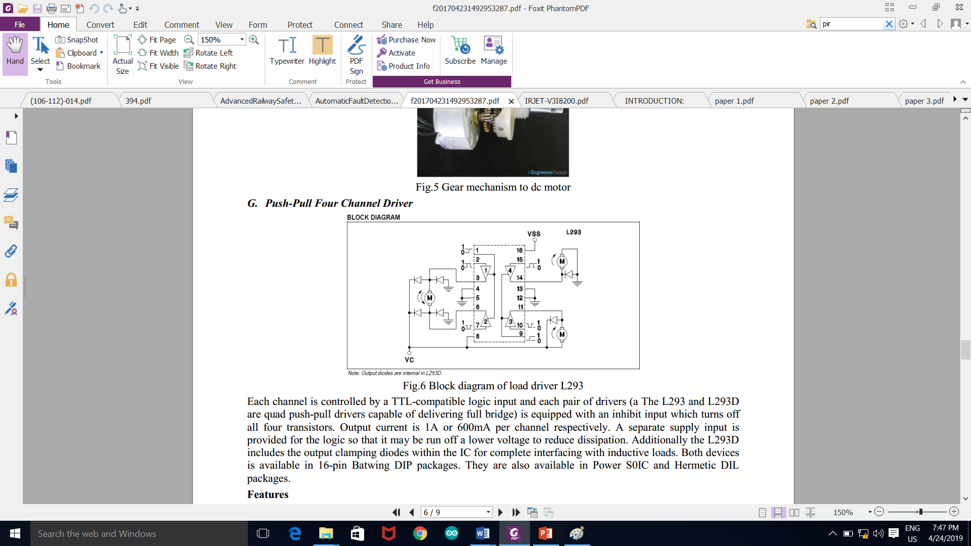

**Features**

* Output Current 1A Per Channel (600mA for L293D)
* Peak Output Current 2A Per Channel (1.2A for L293D)
* Inhibit Facility
* High Noise Immunity
* Separate Logic Supply
* Over-Temperature Protection

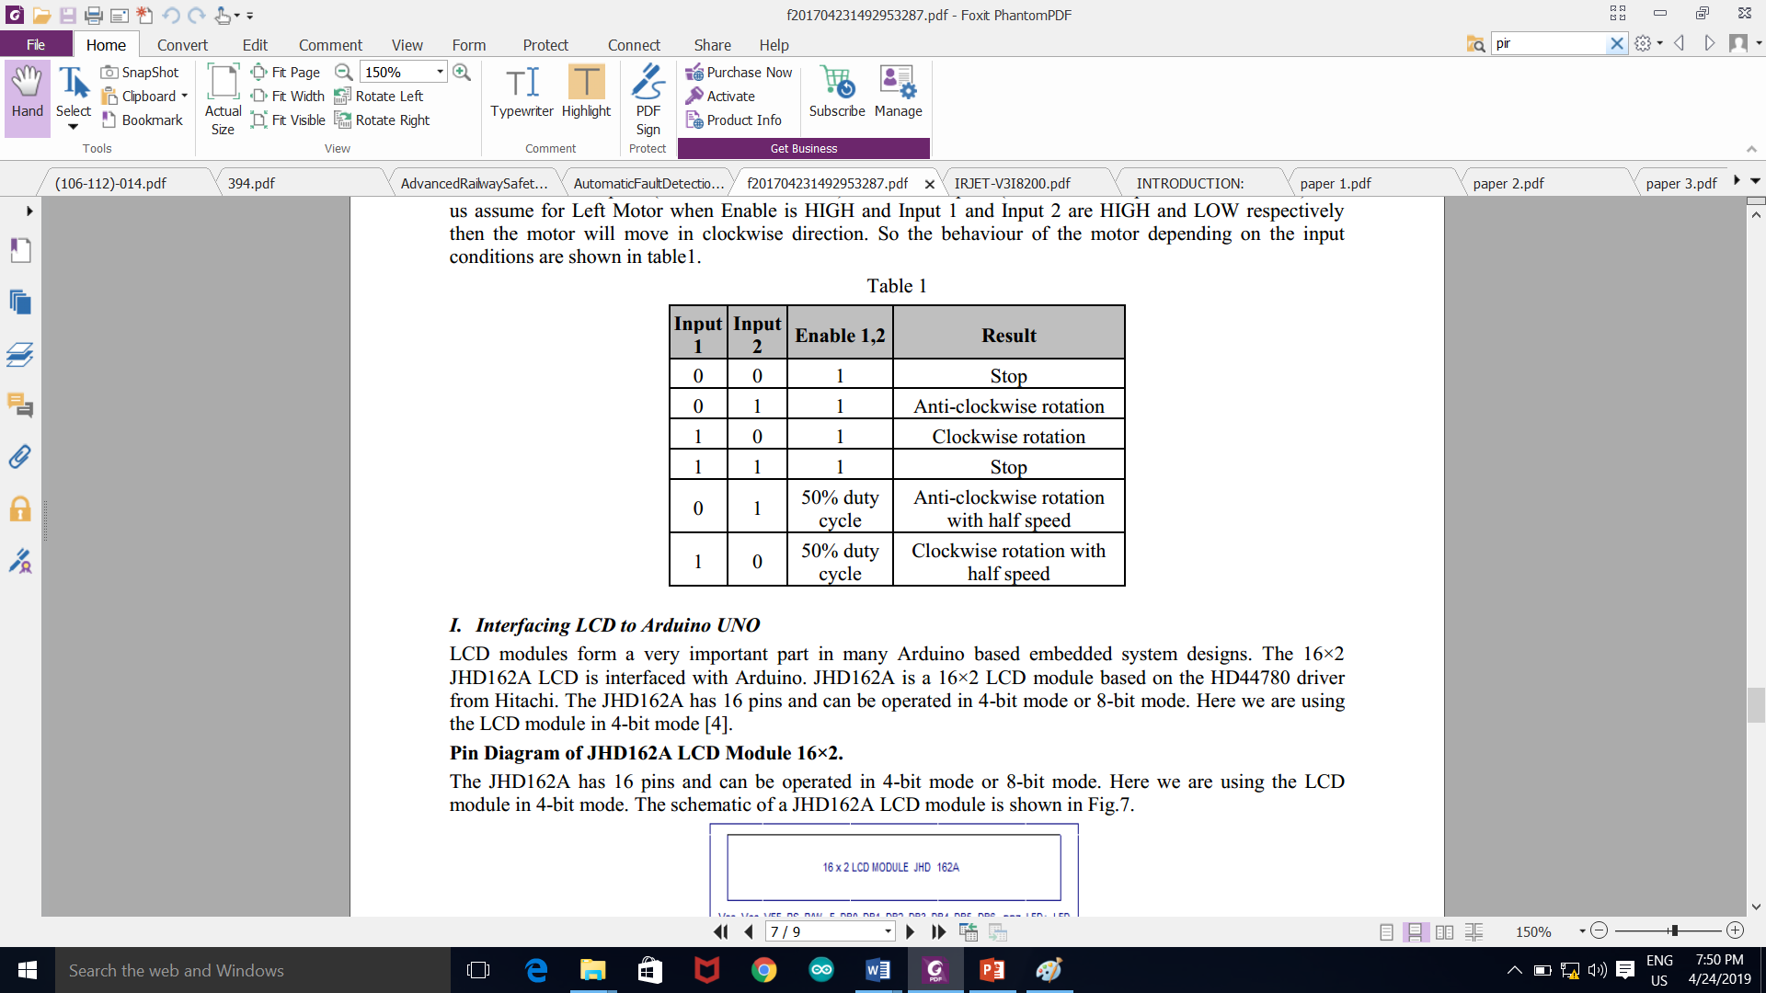

* **PIR SENSOR**

Types of IR sensors. There are basically twotypes of IR sensor: Passive IR sensors and Active IR sensors. Passive Infrared Sensors (PIR sensors) do not need an infrared source to operate. PIR sensors detect the infrared rays emitted.

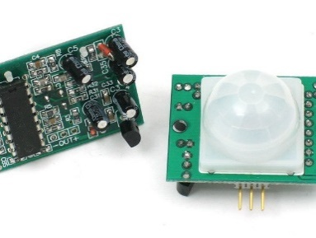

An infrared sensor is an electronic device, that emits in order to sense some aspects of the surroundings. An IR sensor can measure the heat of an object as well as detects the motion. These types of sensors measure only infrared radiation, rather than emitting it that is called as a passive IR sensor.The sensor has very good and stable response even in ambient light or in complete darkness. When the sensor is idle, both slots detect the same amount of IR, the ambient amount radiated from the room or walls or outdoors. When a warm body like a human or animal passes by, it first intercepts one half of the PIRsensor, which causes a positive differential change between the two halves.

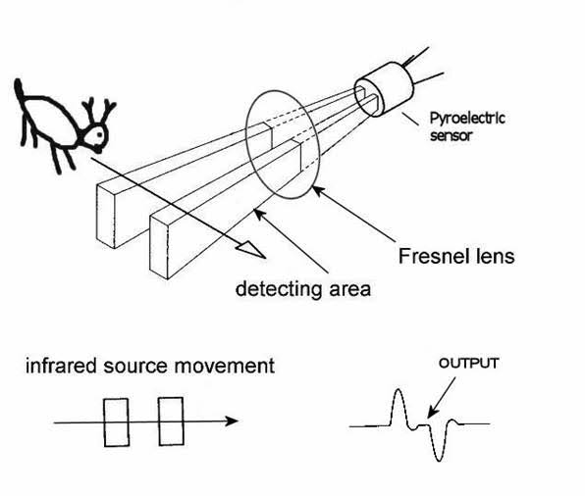

* **Accelerometer sensor**

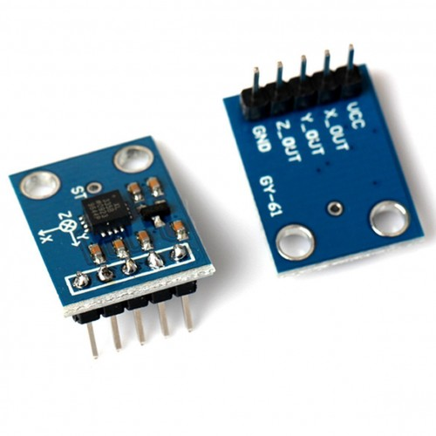

Fig 4.5: accelerometer sensor

An accelerometer is an electromechanical device used to measure acceleration forces. Such forces may be static, like the continuous force of gravity or, as is the case with many mobile devices, dynamic to sense movement or vibrations. Acceleration is the measurement of the change in velocity, or speed divided by time. There are many different ways to make an accelerometer! Some accelerometersuse the piezoelectric effect - they contain microscopic crystal structures that get stressed by accelerative forces, which causes a voltage to be generated. Another way to do it is by sensing changes in capacitance. Accelerometers have a wide usable frequency range where sensitivity is relatively flat. You can choose from two axial types of accelerometers. The most common accelerometermeasures acceleration along only a single axis. This type is often used to measure mechanical vibration levels. In reality, accelerometers have long been used to measuredisplacement. However, it is important to understand that displacementmeasured with an accelerometer is not the same displacementmeasured with shaft riders or eddy current style vibration transducers.

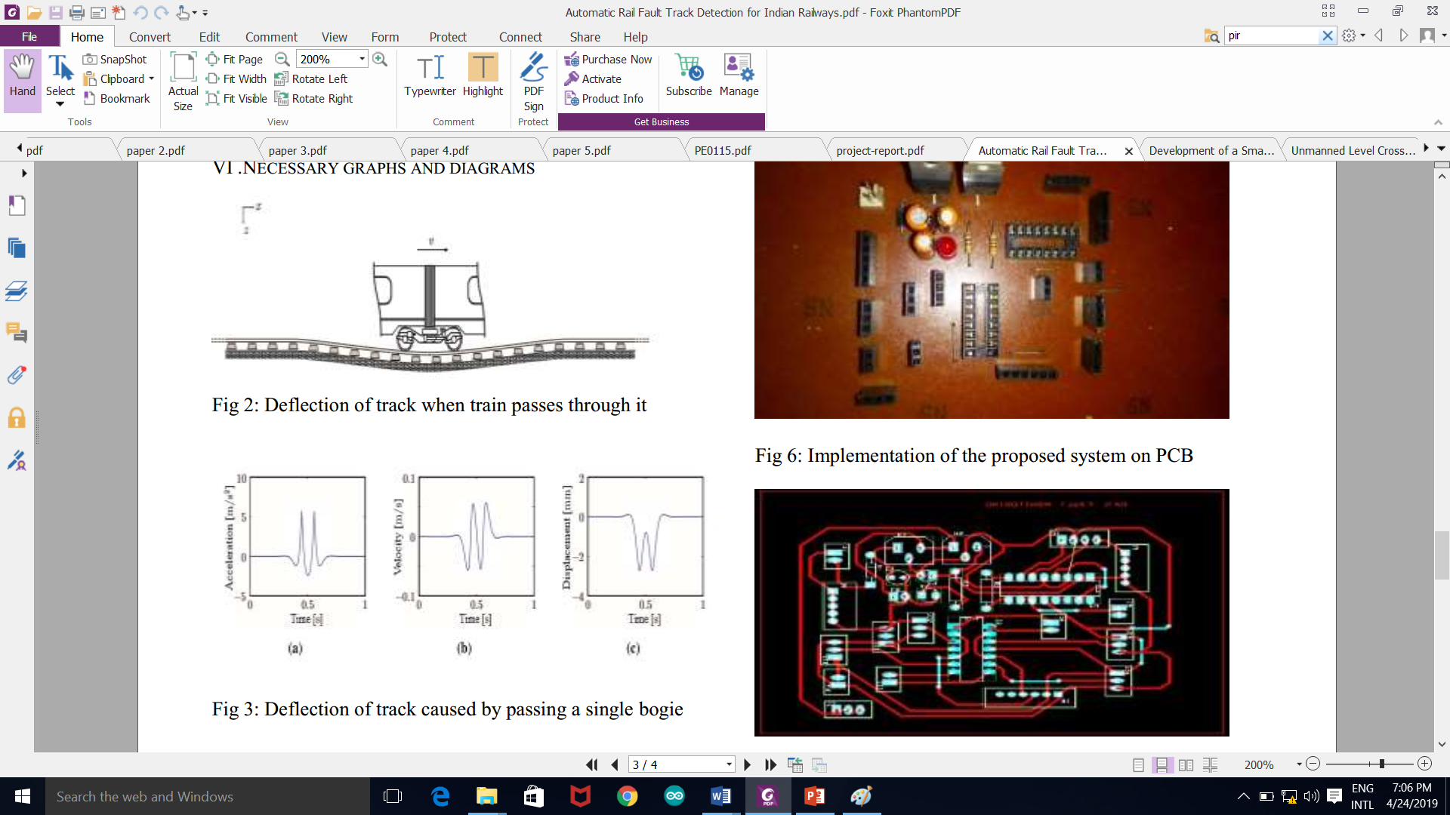

* **SERVO MOTOR**

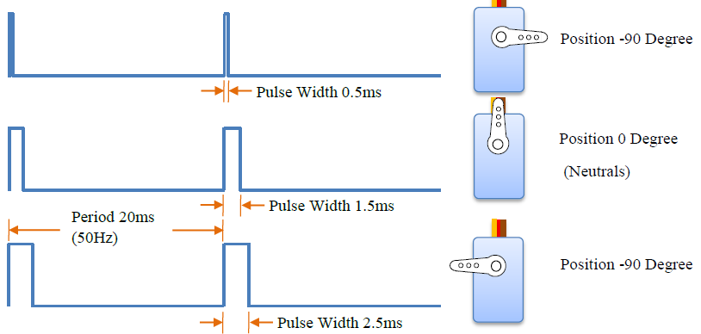

**7.3 TESTING**

|  |  |  |
| --- | --- | --- |
| SPEED = | CRACK LENGTH | RESULTS |
| TRIAL 1 | **1 cm** | **P** |
| TRIAL 2 | **0.75 cm** | **P** |
| TRIAL 3 | **0.50 cm** | **P** |
| TRIAL 4 | **0.25 cm** | **P** |
| TRIAL 5 | **0.10 cm** |  |

Table 7.3 Testing of Crack Detection